**JINJA JOINT EXAMINATIONS BOARD**

**MOCK EXAMINATIONS 2022**

**S850/1 SUB – ICT**

**MARKING GUIDE**

1. **a) Define the term Information as used in computing (1Mark)**

***Information*** *refers to the processed data that makes meaning and is useful*

**b) State any four characteristics of meaningful information (4Marks)**

* *Timely −Information should be available when required.*
* *Accuracy −No possibilities of even slightest errors*
* *Completeness −Information should be whole and not partial.*
* *Comprehensive –should offer all the desired explanations*
* *Uniqueness-Information should be original*

***(any 4X1Mark each)***

1. **How would you ensure safety of hardware in the computer laboratory? (5Marks)**

* *Burglar proofing*
* *Fit strong locks, doors, windows and roofing*
* *Employ security guards*
* *Set up alarms to alert*
* *Use system locks*
* *Electronic locking mechanism with keys, swipe cards, finger print recognition*
* *CCTV Cameras to keep watch over computer systems and centers*
* *Installing Heating, Ventilation and Air Conditioning (HVAC)*
* *Do safe well insulated cabling.*
* *Keep the circuits for computer systems separate from all other equipment such as printers, copiers and coffee makers*
* *Plug each computer into a surge protector or UPS (Uninterruptible Power Supply Unit)or power stabilisers).*
* *Lay cables along the walls in trunks*
* *install lightening conductors*
* *Minimize Electrical noise / interferences in the computer environment. (how?)*
* *Installing Gaseous fire extinguishers*

***(any 5X1Mark each)***

1. **Consider the file path "E:\2022 and Previous\ICT\ICT_Papers.rar". If you create a subfolder called exams in ICT and then drag the file ICT_Papers.rar into exams.**

**a) What would the new file path look like? (2Marks)**

*E:\2022 and Previous\ICT\exams\ICT_Papers.rar*

**b) Which part of the file path represents; (2Marks)**

1. **Parent folder**

*2022 and Previous*

1. **Harddisk partition**

*E or Local Disk E*.

c) Which program can be used to open the file above? (1Mark)

* *WinZip*
* *WinRAR*
* *PeaZip*
* *7-Zip*
* *B1 Free Archiver*
* *The Unarchiver*
* *IZArc*
* *Bandizip*
* *Etc (phone apps)*

***(any 1X1Mark)***

1. **a) Define the term computer hardware (1Mark)**

*Computer Hardware refers to the tangible components of a computer.*

**b) List four computer hardware components (4Marks)**

* *keyboard*
* *mouse*
* *monitor*
* *system unit*
* *speakers*
* *microphone*
* *webcam*
* *scanners etc*

***(any 4X1Mark)***

1. **a) Define an Operating System (1Mark)**

*An operating system is a generalized program that manages and coordinates all the activities taking place within a computer system*

**b) Mention any four functions of an Operating System (4Marks)**

* *Starting a computer, (Booting the computer)*
* *Providing a user interface*
* *Managing programs*
* *Configuring devices*
* *Monitoring performance*
* *Providing file management*
* *Administering security*
* *Managing resources*
* *Coordinating tasks, and Spooling*
* *Managing memory*
* *Establishing network connections*a)

***(any 4X1Mark)***

1. **Differentiate between a webpage and a website (2Marks)**

*A* ***Webpage*** *is an electronic document with text and graphic images, written in Hyper Text Markup Language (HTML) WHILE*

*A* ***Website*** *is a collection of linked Web pages that has a common theme or focus*

**b) Briefly explain the following as used in websites (3Marks)**

1. **html**

*Hypertext Markup Language, a standardized system for tagging text files to achieve font, colour, graphic, and hyperlink effects on World Wide Web pages.*

1. **http**

*HTTP is an application layer protocol designed to transfer information between networked devices and to load web pages using hypertext links*

1. **Hyperlinks**

*Highlighted keywords and images that lead to related information*

1. **List any five advantages of cloud computing (5Marks)**

* *Lower computer costs*
* *Improved performance*
* *Reduced software costs*
* *Better Security*
* *Instant software updates*
* *Improved document format compatibility*
* *Unlimited storage capacity*
* *Increased data reliability/ safety*
* *Universal document access*
* *Easier group collaboration*
* *Device independence*

***(any 5X1Mark)***

1. **a) Define the term green computing (1Mark)**

***Green computing*** *is the environmentally responsible and eco-friendly use of computers and their resources* ***OR***

*It is also defined as the study of designing, engineering, manufacturing, using and disposing of computing devices in a way that reduces their environmental impact.*

**b) Mention any four impacts of Artificial Intelligence on everyday life. (4Marks)**

* *Accurate prediction of weather*
* *Increased leisure time*
* *Safer transport*
* *Increased Personal safety*
* *Improved medical care*
* *Accept the negatives as well*

***(any 4X1Mark)***

1. **Consider the text below;**

Revelation 6:5-6 King James Version

5 And when he had opened the third seal, I heard the third beast say, Come and see. And I beheld, and lo a black horse; and he that sat on him had a pair of balances in his hand.

6 And I heard a voice in the midst of the four beasts say, A measure of wheat for a penny, and three measures of barley for a penny; and see thou hurt not the oil and the wine.

1. **Which office application program is the most suitable for entering the above text into a computer (1Mark)**

*MS Word or any Word processing program.*

*NB: Accept MS Pub*

1. **List any four features of the above application that can be used to emphasise the above text. (4Marks)**

* *Bold*
* *Italic*
* *Underline*
* *Fonts(color, size)*
* *Text highlight color*
* *Text effects*
* *Shading etc*

***(any 4X1Mark)***

1. **Mention five ways computers are used in the field of education (5Marks)**

* *Computer Assisted Instruction CAI*
* *Computer Aided Learning (CAL)*
* *Computer Aided Assessment (CAA)*
* *School Administration and Management Systems. (SAMS)*
* *Creating school websites for sharing information with the public*
* *Students’ Report Cards are produced electronically*
* *Production of error free timetables*
* *E-learning and increased presence of virtual universities*
* *Use of screen readers for the visually impaired*
* *Use of simulation software to perform difficult or dangerous experiments in class*

***(any 5X1Mark)***

1. **Your computer does not display any icon on the desktop. You try creating a new folder but it still does not show up.**
2. **Write down the steps you would follow to overcome the above challenge. (3Marks)**

* *Right Click on the desktop*
* *Point on View*
* *Select View Desktop Icons*

1. **Mention any two default desktop icons (2Marks)**

* *This PC/Computer*
* *Network*
* *Control Panel*
* *Recycle Bin*

***(any 2X1Mark)***

1. **a) Differentiate between a printer and a scanner. (2Marks)**

|  |  |
| --- | --- |
| Printer | Scanner |
| * *Output* | * *Input* |
| * *Produces hardcopy* | * *Produces Softcopy* |
| * *High maintenance costs* | * *Low Maintenance costs* |
| * *Bulky/Bigger in size* | * *Smaller in size* |

***(any 1 differenceX2Marks)***

**b) Briefly explain any three forms of output given by the computer. (3Marks)**

* *Audio*
* *Visual*
* *Print/hardcopy/Braille Dots*
* *3D Objects*

***(any 3X1Mark)***

1. **Outline any five characteristics of a good computer software (5Marks)**

* *provides the required functionality.*
* *is usable by real (i.e. simple) users.*
* *is predictable, reliable and dependable.*
* *functions efficiently.*
* *has a "life-time" (measured in years).*
* *provides an appropriate user interface.*
* *is accompanied by complete documentation.*
* *can be easily customized/configured.*
* *can be "easily" maintained and updated.*

***(any 5X1Mark)***

1. Mention any five social media platforms represented in the picture below: (5Marks)



* *Instagram*
* *YouTube*
* *Facebook*
* *WhatsApp*
* *LinkedIn*
* *Snapchat*
* *Twitter*
* *TIKTOK*
* *Pinterest*

***(any 5X1Mark)***

1. **Explain the following elements of data communication (5Marks)**
   1. **Sender**

*The computer or device that generates and sends data*

* 1. **Receiver**

*The device or computer that receives the message*

* 1. **Messages**

*is the information or data to be communicated*

* 1. **Transmission media**

*This is the physical pathway by which a message travels from sender to the receiver.*

* 1. **Protocols**

*A set of rules that allow devices to exchange information*

1. **State any five factors limiting the full exploitation of ICTs by the SMEs in Uganda (5Marks)**

* *lack of e-business / e-commerce infrastructure;*
* *lack of skills to develop and maintain interactive websites; and*
* *the use of obsolete technologies.*
* *high cost of internet connectivity;*
* *security issues concerning payments;*
* *Shortage of skills.*
* *limited and poor-quality bandwidth;*
* *lack of security guarantees;*
* *inadequate legislative framework;*
* *frequent internet downtime;*
* *slow internet access;*
* *high taxation; and*
* *inadequate technical support.* ***(any 5X1Mark)***

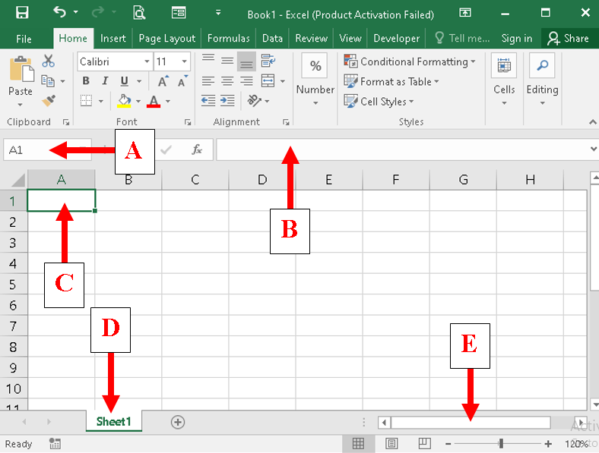

**Name the parts labelled (5Marks)**

**A**…*Name Box*

**B**…*Formula Bar*

**C**…*Cell*

**D**…*Sheet Tab*

**E**…*Horizontal Scroll Bar*

1. **Outline any five factors to consider before buying a computer. (5Marks)**

* *The Processor Speed*
* *Size of RAM*
* *The manufacturer/Brand*
* *Harddisk capacity and speed*
* *Extra ports/peripherals available*
* *Power Consumption*
* *Physical Size/Bulkiness*
* *Price*
* *Software installed/compatible with*
* *Warranty*

***(any 5X1Mark)***

1. **Briefly explain the following terms as used in software (5Marks)**
   1. **Freeware**

*Freeware is copyrighted software provided at no cost by an individual or a company that retains all rights to the software*

* 1. **Shareware**

*Shareware is copyrighted software that is distributed at no cost for a trial period.*

* 1. **Open source**

*Open-source software is software provided for use, modification, and redistribution at no cost.*

* 1. **Custom software**

*Custom software is tailor-made software, which is developed at a user's request to perform specific functions.*

* 1. **Off-the-shelf**

*This refers to packaged software that is designed to meet the needs of a wide variety of end users*

1. **List any 3(three) and 2(two) advantages and disadvantages of using internet respectively**

**Advantages** (3Marks)

* *Interactive communication*
* *Resource sharing*
* *Facilitates Research*
* *Entertainment tools for leisure*
* *Online services*
* *Information on the World Wide Web*
* *Telecommuting*
* *Large storage*
* *Accessible 24/7* ***(any 3X1Mark)***

**Disadvantages** (2Marks)

* *Computer viruses*
* *access to unsuitable material*
* *Theft of Personal information*
* *Spamming*
* *Cyber bullying*
* *Some people get addicted to the internet*
* *The initial cost of connecting to the internet is high* ***(any 2X1Mark)***

END